CURRICULUM VITAE

Name: Reeta Kumari  Guardian’s Name: Dharam Dass  Category: Scheduled Caste (SC)  Permanent Address: Vill. Dashot, P.O. Sianj, Tehsil Chachiot (Gohar), Distt. Mandi, Himachal Pradesh, Pin – 175029, India  Correspondence Address: Room No. 202, Koyna Hostel, Jawaharlal Nehru University, New Delhi, Pin – 110067, India  Mobile: 9990666487; Email: kiranjnu1994@gmail.com | 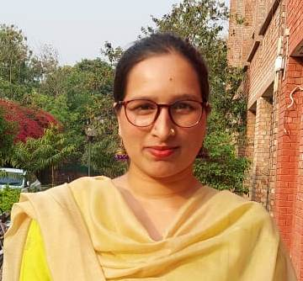

Academic Qualifications
Class | Subjects | Board/  University | Year | Marks Obtained | % | Division
10th | Eng Maths Hindi SST Science, IT Skt. | Himachal Pradesh Board of School Education Dharamshala | 2009 | 451/700 | 64.42 | First
12th | Pol. Science, Eco. Eng. Hindi Phy. Edu. | Himachal Pradesh Board of School Education Dharamshala | 2011 | 397/500 | 79.40 | First
BA | Pol. Science, Eco. Eng Gen.Skt. | Himachal Pradesh University, Summer Hill Shimla | 2014 | 759/1000 | 75.90 | First
MA | Political Science | Himachal Pradesh University, Summer Hill Shimla | 2016 | 1089/1600 | 68.06 | First
MPhil | Centre for Russian and Central Asian Studies (SIS) on Democracy and Electoral System in Kazakhstan, 1991-2017 under the supervision of Prof. Phool Badan | Jawaharlal Nehru University (JNU) | 2018 | NA | 76.20 | First
PhD | Centre for Russian and Central Asian Studies (SIS) on Russia-China Strategic Engagement and its Implications for India, 2001-2019 under the supervision of Prof. Phool Badan | Jawaharlal Nehru University (JNU) | Pursuing | NA | - | NA
UGC-NET | Political Science | UGC | Dec 2018 | NA | qualified

Research Details
M. Phil: on Democracy and Electoral System in Kazakhstan, 1991-2017 under the supervision of Prof. Phool Badan
PhD: on Russia-China Strategic Engagement and its Implications for India, 2001-2019 under the supervision of Prof. Phool Badan
References:
Prof. Phool Badan, Professor in Centre for Russian and Central Asian Studies (CRCAS) School of International Studies (SIS), Jawaharlal Nehru University (JNU), New Delhi
phoolbjnu@gmail.com (011-26704365)
Prof. Swaran Singh, Professor and Chairperson of the Centre for International Politics, Organization and Disarmament (CIPOD), School of International Studies (SIS), Jawaharlal Nehru University (JNU), New Delhi
ssingh@jnu.ac.in (011-26704368)
Membership in a Professional Body
Administrative responsibility done Rapporteur in two-days International Webinar of Indian Institute of Human Security and Governance on Gender Politics and Global Politics, 2021

