Curriculum Vitae
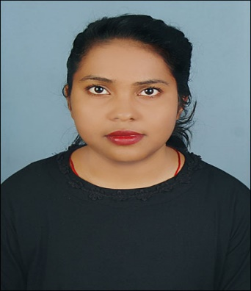
Dr. Neha Kumari Murai
Personnel Information

Email : nehamuraicuj@gmail.com
Contact No. : 9776091342, 7978893230
Mother’s Name : Sarita Murai
Father’s Name : Banwari Murai
DOB : 04/07/1993
Gender : Female
Category : General
Language Known : Hindi, Odiya, English
Address : At- Bhattapara, P.O/P.S-Rajgangpur
Dist.-Sundargarh, Odisha
Pin-770017
Academic Details

Sl. No. | Name of exam Passed | Name of the Board/ University | Year of passing | Total mark | Mark secured | Percentage | Division
1. | 10th/HSC | BSE, Orissa | 2008 | 800 | 486 | 60% | 1st
2. | +2 | CHSE, Orissa | 2010 | 600 | 334 | 55% | 2nd
3. | B.A | Sambalpur University | 2013 | 1800 | 1193 | 66% | 1st class with distinction
4. | M.A | Ravenshaw University | 2015 | 1000 | 704 | 70.4% | 1st
5. | Ph.D. | Central University of Jharkhand | Awarded  2020 | Nil | Nil | Nil | Nil
Technical Qualification

- Completed ‘DCA’ with ‘A’ grade.
Paper Publications

- Contributed a chapter titled India-Vietnam: Strengthening Ties for the book India’s Relations with the World under the Leadership of Narendra Modi, edited by Dr. Sumant Kumar. Avon Publications, ISBN: 978-93-8183-994-2, New Delhi.

- Contributed a chapter titled India-Sri Lanka: Re-energizing Relationship for the book Internal Changes in South Asia: Challenges and Opportunities edited by Dr. Bibhuti Bhusan Biswas. Indu Book Services, ISBN: 978-93-85754-17-2, New Delhi.

- Published a research paper titled, “Human Security and Health: An Overview” in Research Highlights.Vol.4 (4):2017, p.29-24.

- Published a research paper titled “Globalization and Risk to Health: An Overview” in International Journal of Research and Analytical Reviews.Vol.5 (3):2018, p.498-502.

- Published a paper titled “World Health Organisation under Scrutiny amid Covid-19” in Mukt Sabd Journal. Vol.9 (8):2020, p.1711-1715.

Paper Presented

- Presented a paper on Mountain Echoes: Strengthening Relations between India and Bhutan in National seminar on India’s Soft Power and Cultural Diplomacy organised by Department of International Relations, Central University of Jharkhand, April-11-12, 2016.

- Presented a paper on Look East to Act East: India’s New Asia Pacific Strategy in National Conference on Good Governance: Then, Now and Beyond organised by the Department of Good Governance and Public Policy, Sri Sri University, Cuttack, February 4-5,2017.

- Presented a paper on Medical Tourism in India: Opportunities and Challenges in International Seminar on Internal Changes in South Asia: Challenges and Opportunities organised by Centre for International Relations, Central University of Jharkhand, April 20 -21,2017.

- Presented a paper on Odisha’s Relationship with Indonesia in International Conference on Odisha 2036: Society and Politics organised by Department of Political Science, Ravenshaw University, Cuttack, December 9-10, 2017.
- Presented a paper on Democracy in Myanmar: Challenges Ahead in the Tri-department National Seminar on Challenges of Democracy and Development in South and South East Asia organised by Department of Political Science, Department of Economics, and Centre for Urban Economic Studies, University of Calcutta, January 4-5, 2018.

- Presented a paper on An analysis of Indian Democracy: Problems and Prospects in National Seminar on Indian Democracy at 70: Challenges Ahead organised by Jawaharlal Nehru College, Chakradharpur, April 16-17, 2018.

- Presented a paper on Understanding Health Diplomacy in International Conference on Soft Power and Public Diplomacy in India and China organised by Department of International Relations in collaboration with Department of Education, Central University of Jharkhand, Brambe, Ranchi, February 21-22, 2019.

